Task 1 - Http Session, Http Methods, Http Status codes

1. List few differences between HTTP and HTTPS

HTTP:

* Http stands for hypertext transfer protocol.
* It uses port number 80 for communication.
* Http is not a secure way of transferring data

HTTPS:

* Https stands for hypertext transfer protocol secure.
* It uses port number 443 for communication.
* It is a secure way of transferring data because of encryption.

2. List down various HTTP Methods with short description (GET, POST, PUT, DELETE)

GET:

* HTTP get method is used to retrieve the information from the server.

POST:

* HTTP post is used to send data or information to the server for uploading files,etc.

PUT:

* HTTP put is used to update the data to the server.

DELETE:

* AS the name implies it is used to delete data or some information from the server.

3. List down the various status (response) codes of each series. (at least 4 from each)

Most famous status responses:

**200**:OK , server sends this message when the corresponding request has succeeded.

**400**: Bad Request, could be syntax error,bad url,etc.

**404**: Not Found, the request url is actually not present or shifted somewhere.

**503**: Service unavailable, the request could not proceed because of maintenance or request overloading.

4. Perform GET, POST, PUT, PATCH and DELETE http methods from <https://reqres.in/>and add

screenshot

GET:

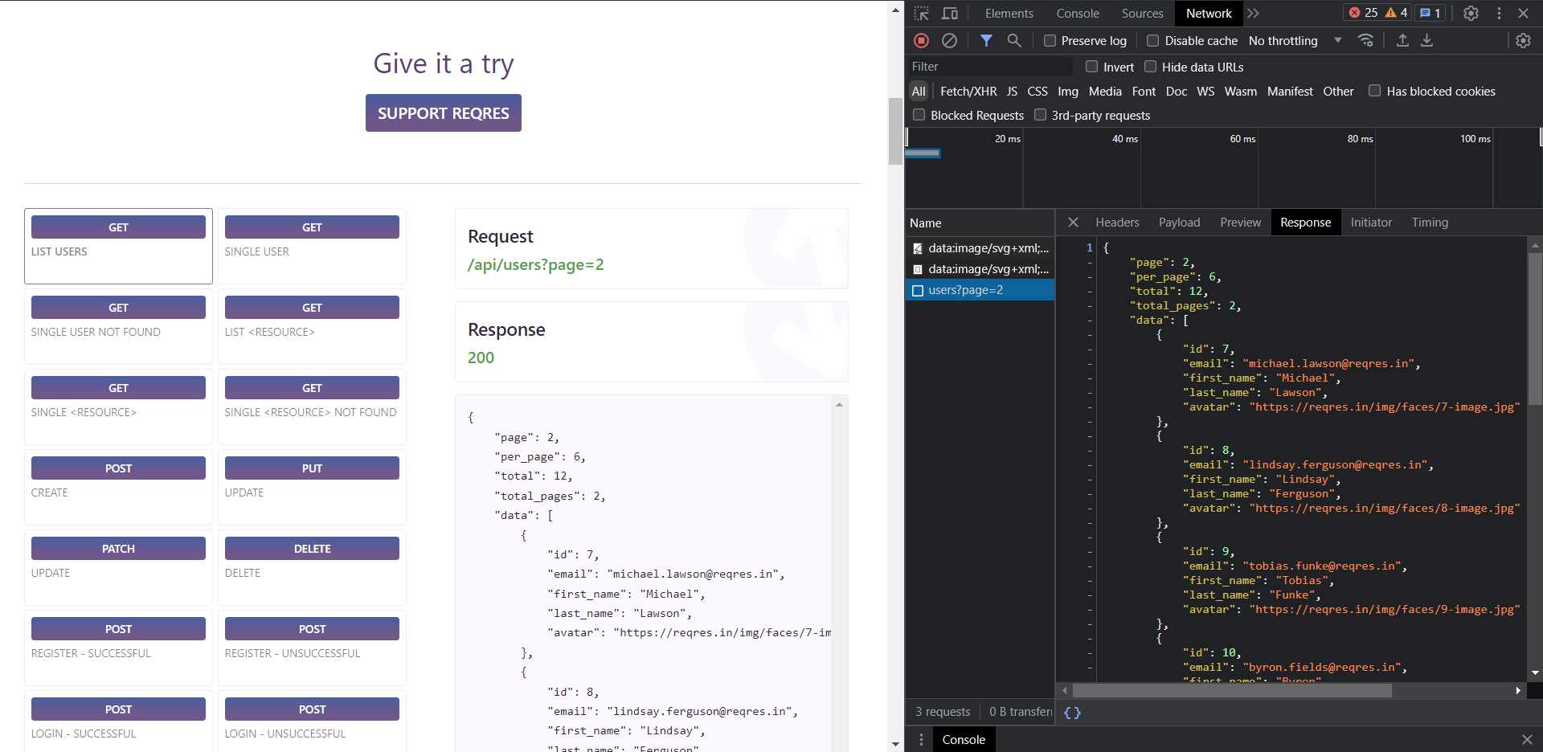

As we can see the given request gives list of all users.

POST:

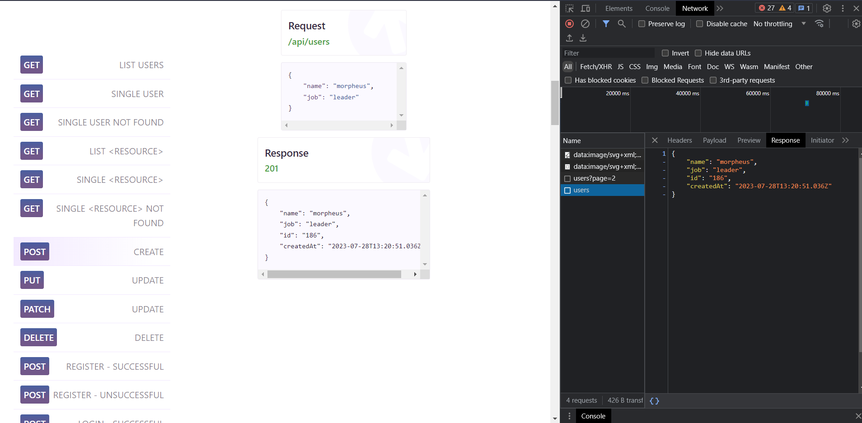

It is used to create user as per above request.

PUT:  
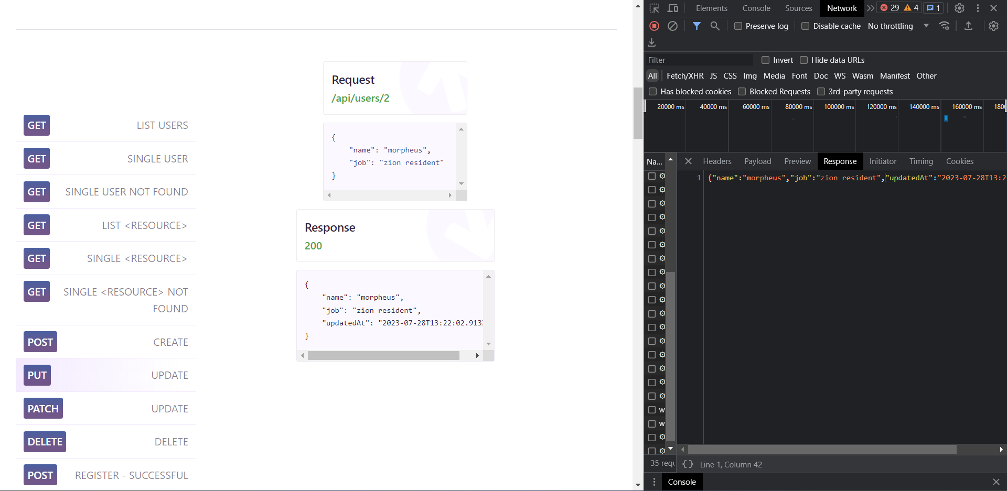

It is used to modify user that created on the post request.

DELETE:  
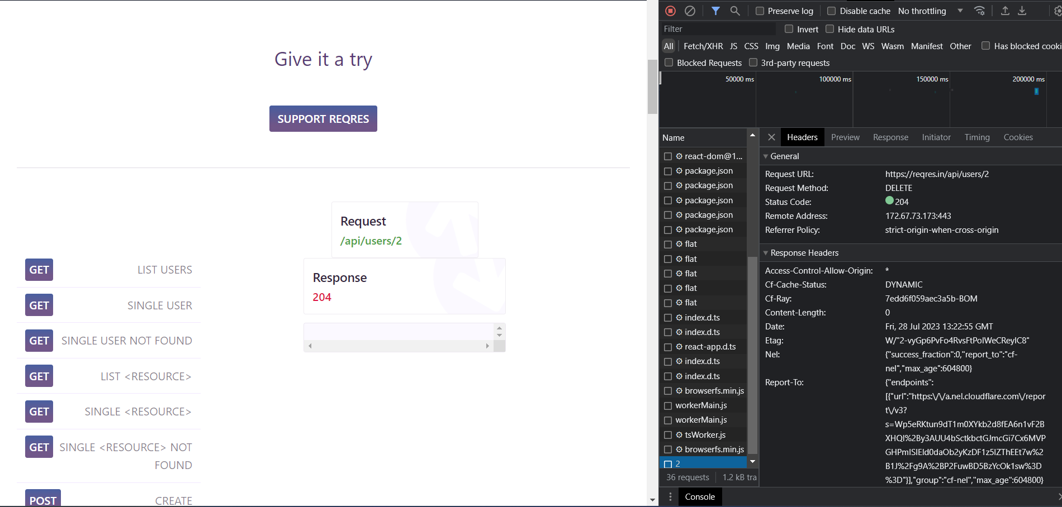

Task 2 - Cache & Cookies, Browsers, Responsive Design

1. List down the latest browser versions for Chrome, Firefox, Chromium Edge and Safari.

Chrome: 115.0.5790.110

Firefox: 115.0.2

Edge: 115.0.1901.188

Safari: 16.4.1

2. How to clear cookies and cache in chrome browser for -

a. All sites

1. Open chrome browser
2. Click on three dots on top right corner
3. Click on more tools
4. There will be an option for clear browsing data and selecting the time range of All time.

b. For any specific site

1. Open chrome browser
2. Click on three dots on top right corner
3. Click on setting
4. There will be options for privacy and security. In that click on see all site data and permissions.
5. Search or find website name and remove the site.

3. Perform analysis of the <https://www.makemytrip.com>/ website for its responsive behavior and

note down the resolutions on which it is not responsive.

1. Make my trip website logo starts to squeeze down after 900 px x 750 px.
2. That’s basically saying for mobile version website is unresponsive
3. The Offer button is working as expected.it shows all offers that are available.
4. The login functionality is working both google sign in and mobile otp verification is working.
5. For all the mobile versions makemytrip website becomes unresponsive i.e you need scroll for all the information on the website.
6. For tablets, the aspect ratio is perfect.